


Master 2 Machine Learning on Sequences
Practical work 3:
Embedded training of continuous Neuro-HMM
training without symbol segmentation

In this session we focus on moving from a pure HMM to a neuro_HMM. We focus on images of strings of digits that are of size $28×L$as shown on figure below. $L<140$ is the image width in pixels and may vary from one image to another because the digits may overlap, which makes the segmentation almost impossible without recognition.
The ground truth is the sequence of classes and does not provide any information about the position of the symbols in the image. Thus, training will proceed without segmentation with embedded training. Contrary to previous experiments, we will now consider the pixel columns of the image as the input frames of the sequences, we give up with discreet HMM.

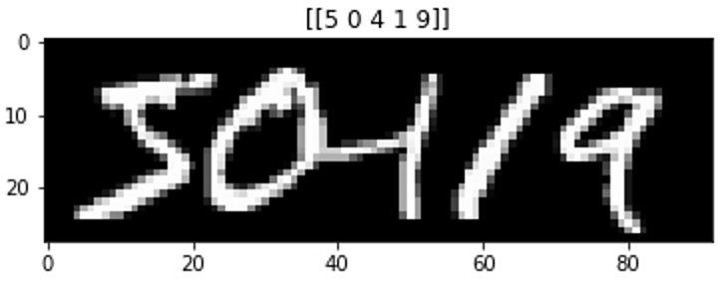
Example of a 5 digits sequence generated from the MNIST dataset.

Neuro HMM architecture
A neuro HMM is a HMM where the emission probabilities are modeled with a neural network. A Multi-Layer Perceptron (MLP) is chosen, with a softmax activation function at its output, which estimates the state posterior probabilities:

$$γ_{t}(s_{k})=P\left(q_{t}=s_{k} | O\right)$$

Every character Neuro_HMM will share the same Neural Network, which all in all makes a number of classes for the MLP equal to:
$$N_{classes}=n_{symbols}×n_{states}$$
with $n_{symbols}=10$ and $n_{states}=5,…10,…15$

The Neuro-HMM equation is the following, where we see the state posteriors divided by the state priors to provide a normalized likelihood of the observation (in red). The transition probabilities and Initial and final probabilities (in blue) remain similar to those of a HMM

$$P\left(O,Q | M\right)∝π_{q_{1}}\prod_{t}{\frac{P\left(q_{t} | o_{t}\right) }{P(q_{t}) }×P\left(q_{t} | q_{t−1}\right)}$$

This equation can simplify to the following one if we consider equi-probable state priors:
$$P\left(O,Q | M\right)∝π_{q_{1}}\prod_{t}{P\left(q_{t} | o_{t}\right) ×P\left(q_{t} | q_{t−1}\right)}$$

Embedded training with a Neuro HMM
We proceed using the following algorithm where one can see the use of mini-batch for training the neuro-hmm.
Also notice that this training scheme only trains the Neural Network, whereas the transition probabilities remain unchanged during training. The Markov Model remains unchanged with a uniform distribution for the left-right model (see the initialization procedure of the Neuro-HMM)
Models : the liste of digit models (the ten digit models)
NN = the initialized MLP
for iteration = 1,…,Max_EM_iter do
for each mini_batch do
EXPECTATION STEP
for n = 1,…,mini_batch size do
GT_Model = Create HMM for GT of example n°n
Compute gamma probabilities for this example with GT_Model
Derive the gamma probabilities for the 10 digit models
Concatenate every frames of the batch
Concatenate every frame predictions of the batch
MAXIMISATION STEP
Train the MLP to predict the Neuro-HMM predictions

Compute train_LogLikelihood
Compute valid_LogLikelihood

if valid_LogLikelihood > previous_ valid_LogLikelihood then
Stroe the NN parameters

The Embedded_Training( ) method in neuro_hmm.py implements this algorithm.

Question 1 : explain the following lines of code
# shuffle the training data at each iteration
l=list(zip(train_data,gt_train))
random.shuffle(l)
train_data, gt_train = list(zip(*l))

Question 2 : in the Embedded_Training() method, what does the M step?

Question 3 : explain the pred_on_batch() method
um batch de que? Pra prever o que?

Question 4 : explain the GT_statesToSymbol_states() method

Question 5: in the forward() and backward() code what are the log_B variables ? What is it for ?
Se nao existe matriz B o que é o log_B ?

Question 6 : Explain the gamma() method

Question 7 : in the method pred_on_batch() explain the following lines of code ?
sum_prob = np.sum(B,axis=1)
for t in range(T):
B[t,:] /=sum_prob[t]

Sliding window
In order to allow the MLP to take account of more context, we introduce a sliding window of size w_width, and stride w_stride. The sliding window takes into account every pixels in the window and is cast into a feature vector of size 28 * w_width pixels or features. This sliding window moves left to right over the image with a step of size w_stride. An image of width T is transformed into a sequence of lenth T/w_stride of feature vectors of size 28 * w_width.

Some examples with w_width =3 and w_stride =2, providing feature vectors of size 84.
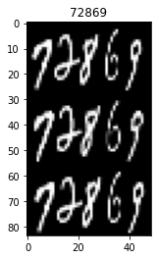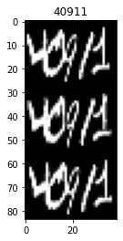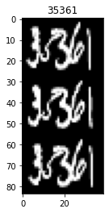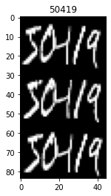

Question 8 : Train a model over 20 epochs with the following configuration:
N_epochs N_states/symbol #train seq batch_size w_width W_stride
10 5 2000 128 3 2
Observe the training loss of the MLP and the Log Likelihood of the Neuro_HMM over time. Explain what happen?

Question 9: Evaluate the performance of the Neuro_HMM on the test set. Explain the recognition algorithm in detail?
What is the algorithm used, why?
What is the kind of HMM used during decoding, why?

Question 10: To provide a better initial model with missing data, we chose to process the first E step using a uniform distribution to predict the HMM states in the pred_on_batch() method. Observe the role of such initialization by viewing the training loss and compare this initialization with a pure random initialization.

Question 11 : Explore training and testing some other models with more and fewer states, and other parameters of the sliding window

Question 12 : Conclusion
- Discuss the capacity of Embedded Training to train with unknown segmentation.
- Discuss the capacity of Neuro_HMM with sliding window to model long range dependencies.
- What is the best configuration you would recommend, why?

10 classes = 30 etats e 10 models

Modelo generativo, para construir uma sequencia de numeros basta selecionar os modelos necessarios para gerar os numeros.

Cada numero é composto de 3 states, entao 5 digitos = 15 states

As estatisticas de cada conjunto de estados é relacionada ao modelo de sua classe, o modelo é mobilizado

Todos os modelos sao treinados ao mesmo tempo sem segmentar a sequencia, considerando os modelos

Usa uma sliding window

stride = 1 seria muito repetitivo, para uma window de wide 3 é razoavel usar stride de 2. Isso divide o tamanho da imagem em 2 apos a convoluçao.

Sequencias nao sao do mesmo tamanho

INTERESSANTE IR ALÉM E ANALISAR O MLP

no HMM queremos melhorar a Log vraissamblance. Para o MLP queremos reduzir a crossentropy , nao é uma classificaçao binaria

para passar de um HMM para um neuro HMM dizemos que

quebra causada na primeira epoch por causa da inicializaçao. Il y a un “sô” (saut?). Ele se inicia no equiprovavel. Na segunda epoch ele entra em rota, começa mal (prevendo pior que o equiprovavel), mas melhora aprendendo com seus erros.
Em um certo momento ele se iguala a inicializaçao aleatoria durante a fase de crescimento.

Eixo x é o numero de batch, nao o numero de epochs, por isso é um numero grande>40

RR = 86%. temos uma tarefa mais complexa que os TPs, uma sequencia de 5 digitos sem separaçao bem definida. Entao estamos satisfeitos com esse resultado. É possivel melhorar, usando mais epocas (pois o treinamento nao parecia totalmente finalizado), ou talvez usando um MLP mais complexo.

Best path, cada numero sao 2 pixels,
etat0-4 = digit0
etat5-9 = digit1
etat10-14 = digit2
…
etat45-49 = digit9

é possivel que ele preveja um numero a mais ou a menos. Como ele contabiliza esse erro?
Ex:GT=78901, prev=718901. É contabilizado um erro de inserçao. É possivel haver erros de omiçao de de substituiçao. Erro pela distancia de levenstein com peso de 1 para cada erro.

Ergodic, o que é? Modelo que autoriza qualquer digito apos qualquer outro digito

